Energy & Resource Efficiency – Increasing Competitiveness in NI Businesses

Energy and resources effect all business and can have a major impact on operations in terms of cost and productivity. Increasing efficiency in these areas, not only brings increased competitiveness, but also significant environmental benefits.

The Energy and Resource Efficiency Team in Invest NI delivers a suite of support, including specialist advice and investment capital, to enable NI businesses to become more efficient, resilient and competitive in their day to day operations.

Equipped with in house Technical Advisors who are specialists in their fields, our team can support and signpost businesses to identify and achieve cost savings in the consumption of water, energy and raw materials. Our support includes:

Technical Consultancy

The Invest NI Technical Consultancy Support helps NI businesses identify areas for increased efficiency and cost savings.

An Invest NI Technical Advisor will meet with your business to understand your energy and resource efficiency needs and challenges. They will advise on a roadmap to improved efficiency and will appoint a relevant specialist to complete a bespoke and fully funded project. Projects can include technical audits, feasibility studies and advice, complete with a report, recommendations, and relevant business cases.

This process will help business identify projects that will improve their business operations and give them the necessary information for investment decisions regarding energy and resource efficiency.

Technical Consultancy is available to all businesses with an annual energy and resource spend in excess of £30k. Support is available under a range of specialist areas, including:

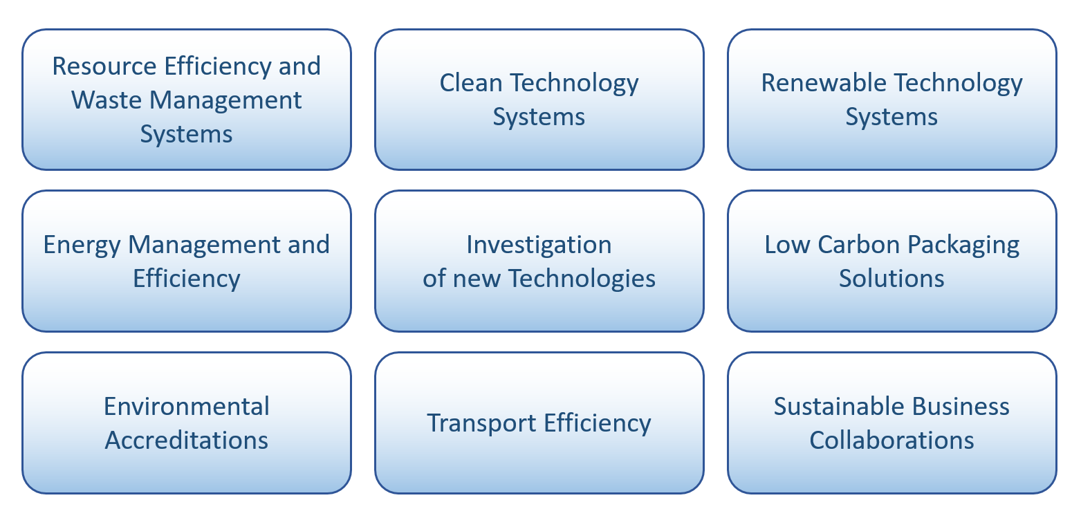

Resource Matching

Waste and redundant materials is often a by-product of business operations and this can be costly to dispose of or to store. Invest NI’s Resource Matching service offers opportunities to convert redundant materials of one business, into a resource for another business – helping to add value and reduce business costs for all parties.

A team of highly skilled and experienced advisors are available to help your organisation. We can find solutions to use your wasted resources and match you with other organisations that can make use of these to the mutual benefit of both parties. The service is delivered by International Synergies NI Ltd on behalf of Invest NI.

By engaging in this service, businesses can benefit from:
- Cost Savings
- Opportunities to generate additional sales
- Productivity improvements
- Prolonged life of resources and carbon abatement

This service is open to the wider business base.

Resource Efficiency Capital Grant

If your business has identified a project that will reduce the consumption of water, raw materials or waste production, Invest NI can provide investment support.

Our Resource Efficiency Capital Grant offers support of up to £50k to help with the purchasing of resource efficient equipment that will drive productivity in your business. The rate of support is based on company size (a maximum of 10% of total eligible project costs for large businesses, 20% for medium and 30% for small and micro).

We operate competitive grant calls at least once a year. If you are interested in this support, please contact the ERE team for advice and further information.

Some of the technologies we have funded include:

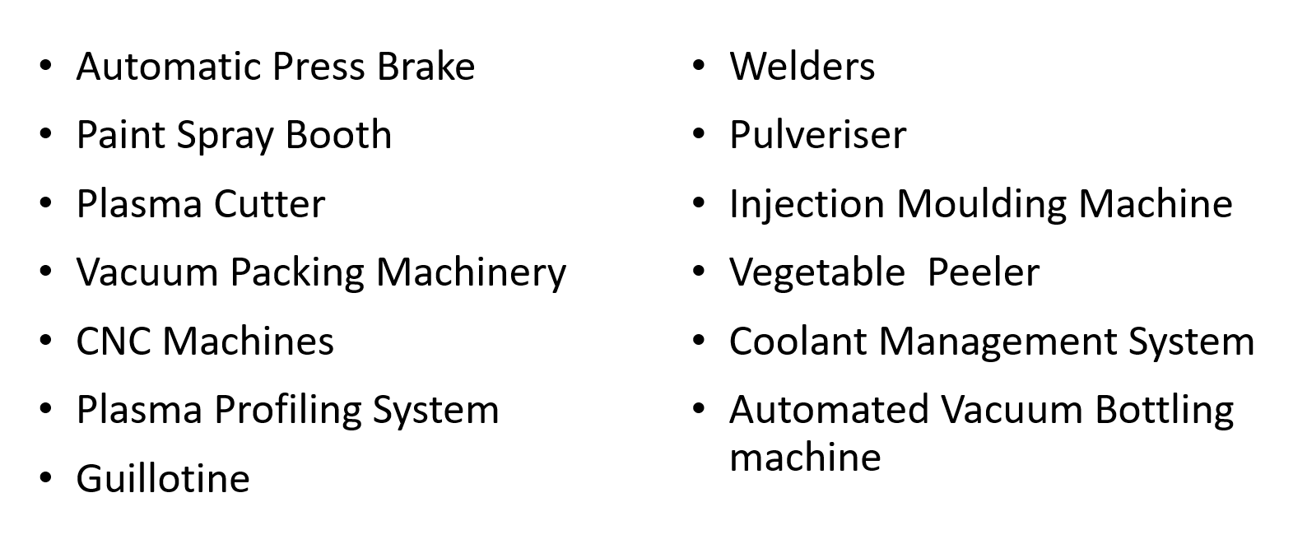

This support is open to Invest NI client companies only.

Contact Info
Contact a member of the team today: E:ere@investni.com T:08001814422 W:www.investni.com

